BansilalRamnathAgarwal Charitable Trust’s

Vishwakarma Institute of Information Technology

*(Department of Electronics & Telecommunication)*

**

*A*

*Project entitled*

**“Electronic Footwear for orthopedic patients”**

*Submitted by*

*Yash Kamate(412006)*

*YogitaKhodade(412022)*

*Nikhil Kulkarni(412026)*

Project & Seminar

B.E. Electronics &Tele-Communication

*of*

*University of Pune*

*Under the supervision of*

Mr. S. V. Kulkarni

|  |
| --- |
| *Domain* |
| Embedded |

*Year 2015 – 2016*

BansilalRamnathAgarwal Charitable Trust’s

Vishwakarma Institute of Information Technology

*(Department of Electronics & Telecommunication)*

**CERTIFICATE**

This is to certify that the project *“Electronic Footwear for orthopedic patients”*has been successfully completed by

*Yash Kamate(412006)*

*Yogita Khodade(412022)*

*Nikhil Kulkarni(412026)*

It is an original work done by the students and has not been submitted previously by any other student/students for the award of any other degree of same or other university.

The work is done, on the basis of the work allotted to these students, based on various Project ideas presented by them.

This project report is being submitted as a part of the subject Project and Seminar atB.E.-E&TC/B.E Electronics.

Mr. S. V. Kulkarni Dr. P.D. Khandekar

Project Guide H.O.D- E& TC

### ACKNOWLEDGEMENT

This whole project took a lot of time and effort to make it working. We extend our gratitude to our internal project guide Prof**. Mr. S. V. Kulkarni** for the extremely valuable guidance he has provided us during the course of the project. This project would not have been successful without his timely and helpful inputs. We would like to take this opportunity to thank the Head of Department, Electronics and Tele-communication, Prof**. P.D.Khandekar** , for providing us with a highly conductive studying and working environment for this project. We are also thankful to all those involved directly or indirectly in the completion of the project in various aspects, both technical and non-technical .This task would have not accomplished without extensive support of them all.

Thanks and regards.

YashKamate (412006)

YogitaKhodade (412022)

Nikhil Kulkarni (412026)

**INDEX**

|  |  |  |
| --- | --- | --- |
| **Sr. No** | **Contents** | **Page No.** |
| 1. | INTRODUCTION……………………………………………………………... | 5 |
| 2. | INNOVATION ...…………………………………………………….………. | 6 |
| 3. | LITERATURE SURVEY………………………………………………...…… | 7 |
| 4. | BLOCK DIAGRAM…………………………………………………………... | 9 |
| 5. | DESCRIPTIVE PROCEDURE………………………………………………. | 10 |
| 6. | ELECTRONIC AND HARDWARE DESIGN ASPECTS………………….... | 11 |
| 7. | POWER BUDGET……………………………………………………………. | 17 |
| 8. | SOFTWARE ASPECTS………………………………………………………. | 18 |
| 9. | CIRCUIT DESIGN……………………………………………………………. | 19 |
| 10. | APPLICATION………………………………………………………………. | 20 |
| 11. | CONCLUSION......…………………………………………………………… | 21 |
| 12. | REFERENCES……………………………………………………………..….. | 22 |

### INTRODUCTION

* Partial weight-bearing instructions are commonly given to orthopaedic patients and are an important part of post-injury and/or post-operative care. However, the ability of patients to comply with these instructions is poorly defined**.**
* Orthopaedic patients are often instructed on how much weight to bear through an injured or postoperative extremity.
* Common instructions are for touch-down weight bearing, partial weight bearing (often prescribed in number of pounds), or weight bearing as tolerated.
* Weight bearing is restricted based on the fear that excessive weight seen by an injured or operative site will lead to implant failure (deformation i.e. plastic failure or breakage i.e. brittle failure), therefore affecting the fracture stability and alignment.
* Conversely, the rationale for advancing weight bearing is that repetitive loads can stimulate osteoblastic activity in fracture patterns and fixation constructs in load-bearing extremities.
* Therefore, the difficulty in ambulating an orthopaedic patient with an affected lower extremity is the dual desire to both protect the surgical construct by limiting weight while simultaneously stimulating bone growth by increasing weight bearing.
* Reasons for patient non-compliance with partial weight-bearing instructions include the difficulty in judging pressure over the lower extremities and the difficulty in adequate training methodologies to ensure patient compliance.
* Thus the idea is to design footwear that aids an orthopaedic patient to comply with partial weight bearing instructions.

**2. INNOVATION**

* **Wireless product:** The footwear involves wireless transmission of information regarding partial weight exertions on the affected lower extremities via Bluetooth.
* **Size:** The overall size and weight of the footwear is reduced as compared to similar existing products in the market.
* **User-friendly interface:** The measured data is displayed to the user through an android device (Smartphone).
* **Power consumption:**The footwear exhibits low power consumption as energy from a small battery is sufficient for collecting and recording the required data.

**3. LITERATURE SURVEY**

* Over the past two years there has been increasing interest in developing in-shoe foot plantar pressure systems and recently there have been applications to plantar pressure using both wired and wireless systems.
* Nearly all use off-the-shelf sensors, microprocessors and wireless transmitters, so the end product is bulky and not comfortable to wear by the patients.
* FlexiForce® (Tekscan, USA):In 2011, a paper employed dynamic plantar pressure for human identification using a FlexiForce® (Tekscan, USA) in-sole pressure sensor. They compared the pressure at different positions of key points then identified and classified them using a support vector machine (SVM) running on a PC.
* The system uses wire to transfer data from the sensor to a data acquisition card on a PC and it is reported that the system has 96% identification accuracy.
* WalkinSense®:The system is named “WalkinSense” and consists of a data acquisition and processing unit and eight individual sensors. It appears that only the sensor part is their own development, the rest of the system is similar to FlexiForce® (Tekscan, USA) hardware and software.

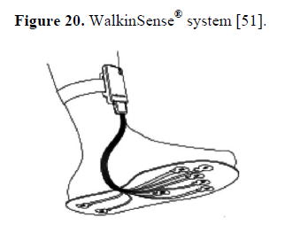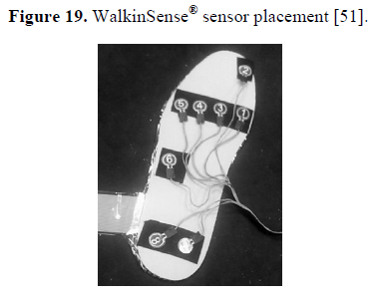

Figure 1. Sensor Placement Figure 2. WalkinSense system

* Few other system :The digital textile sensors by Chang-Ming are small and really flexible but it is wired to a Bluetooth based transmitter device at the belt.
* Both Benocci(fig.3) and Lin Shu(fig.4) used Bluetooth modules to attach to the ankle.

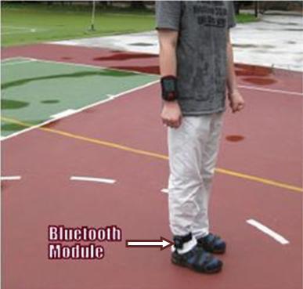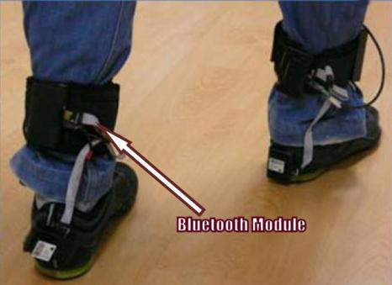

Fig.3 A wireless systems for gait and posture Fig.4 In-shoe plantar pressure measurement

andanalysis system based on fabric analysis based on pressure insoles and

pressure sensing array. Inertial measurement units.

* Even more uncomfortable would be the system proposed by Bamberg where the whole sensor and wireless communication tools are attached to the top of the shoe.
* Although Bamberg has developed the in-shoe gait analysis system but the system is not wearable for daily activities monitoring.

1. **BLOCK DIAGRAM**

***FOOTWEAR***

***PRESSURESENSOR***

***MICROCONTROLLER***

***MOBILE***

***PHONE***

***POWER SUPPLY***

***Bluetooth Module***

**5. DESCRIPTIVE PROCEDURE**

1. **Study and selection of suitable pressure sensor.**

Select low power consumption sensor based on following parameters:

* + - * Hysteresis
      * Linearity
      * Temperature sensitivity
      * Pressure range
      * Sensing area of sensor
      * Operating frequency
      * Repeatability

1. **Study and selection of suitable Microcontroller & Bluetooth module.**

Select a low cost microcontroller which is compatible for Bluetooth transactions

using UART or USB and functionality that satisfies the requirement.

1. **Design of power supply.**

Design a low size compliant power supply that could power the sensor as well as the microcontroller efficiently. Find optimum ways to reduce power consumption, radiation and a safety barrier from bare foot.

1. **Assembly, Testing and implementation of the device.**

Assemble and test the device under various conditions such as uneven pressure application, temperature variations, etc. Check whether the device avoids sensor slipping and can handle burst pressure situations efficiently.

1. **HARDWARE DESIGN AND ASPECTS**

It involves selection of the following components –

* + - * Pressure Sensor
      * Bluetooth Module
      * Microcontroller
      * Battery
  1. **PRESSURE SENSOR :**

There are several pressure sensors available in the market.

* + capacitive sensors
  + resistive sensors
  + piezoelectric sensors
  + piezoresistive sensors.

These sensors provide electrical signal output (either voltage or current) that is proportional to the measured pressure.

Resistive Sensors:

When pressure is applied the sensor measures the resistance of conductive foam between two electrodes. The current through the resistive sensor increases as the conductive layer changes (i.e., decreases resistance) under pressure. FSRs are made of a conductive polymer that changes resistance with force, applying force causes conductive particles to touch increasing the current through the sensors.

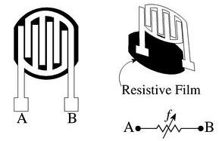

**THE STRAIN GAUGE**

The bonded foil strain gage has a number of desirable characteristics needed to make a good pressure transducer, as follows:

1. Low and predictable thermal effects allow accurate operation over a wide temperature range.Compensation and correction techniques are straightforward.
2. Strain gages can be creep corrected by the manufacturer to match the requirements of the transducer designer.
3. Small size and low mass allows operation over a wide frequency range and minimum sensitivity to shock effect.
4. Because the strain gage is fully bonded to the transducer’s sensing element, there are no mechanical connections to compromise ruggedness and dynamic performance.
5. The strain gage changes resistance with strain, increasing under tensile strains and decreasing when in compression. Since it is essentially insensitive to supply voltage frequency, it can be used with AC or DC systems.
6. The cost of the strain gage is relatively low and readily available in a variety of shapes, sizes and materials. Strain gages have excellent repeatability and linearity over a wide range of strains.

In terms of designing a strain gage pressure transducer, there are two fundamental considerations. One is the mechanical pressure-sensing element and the other is the electrical strain gage bridge.

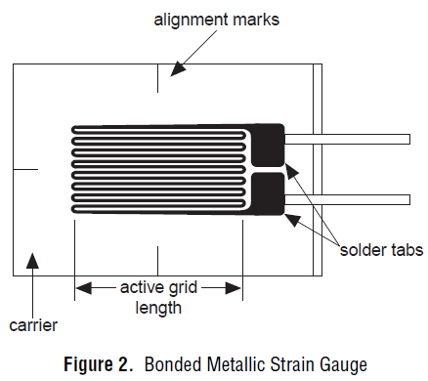

* 1. **BLUETOOTH MODULE :**

Bluetooth module Requirements:

* Maximum power output of Bluetooth module:**2.5 - 10 mW.**
* Distance between your two Bluetooth devices receiver and transmitter:**10 meters.**
* Mode of communication: **UART.**
* Low size.
* Supply Voltage : **3-5V**

Comparison between commercially available Bluetooth modules:

|  |  |  |  |  |  |
| --- | --- | --- | --- | --- | --- |
| **Parameters** | **HC-04** | **HC-05** | **RN-41** | **RN-42** | **RN-4020** |
| **1.Power Output range** | 2.5 mW | 2.5 mW | 100mW | 2.5 mW | 5.02 mW |
| **2.Distance covered** | 10 meter | 10 meter | 100 meter | 10 meter | 100 meter |
| **3.Communication** | UART | UART | UART and USB | UART and USB | UART,SPI and USB |
| **4.Dimensions** | 28 x15 x 2.35mm | 28 x 15 x 2.35mm | 13.4 x25.8 x 2 mm | 13.4 x25.8 x 2 mm | 11.5 x 19.5 x 2.5 mm |
| **5.Supply voltage** | 3-4.2 V | 3-4.2 V | 3-3.6 V | 3-3.6 V | 3-3.6 V |

Bluetooth module Selection:

* From above comparisons we verify that **RN-4020** Bluetooth module suits the requirements perfectly.
* The RN4020 can be used with a low cost microcontroller for intelligent Bluetooth Low Energy applications.
* For simple sensor applications, the RN4020 internal scripting capabilities enable basic functions to be implemented without the need for external host MCU or software development tools.
  1. **MICROCONTROLLER :**

Requirement:

* + Low cost
  + Compatible for Bluetooth transactions using UART or USB
  + Sufficient storage.

|  |  |  |  |  |
| --- | --- | --- | --- | --- |
| **Features** | **PIC18F2420** | **PIC18F2520** | **PIC18F4420** | **PIC18F4520** |
| **Program Memory**  **Flash 8/16-Bit**  **(bytes)** | 16K | 32K | 16K | 32K |
| **Program MemorySingle-Word**  **Instructions** | 8192 | 16384 | 8192 | 16384 |
| **Data Memory SRAM(Bytes)** | 768 | 1536 | 768 | 1536 |
| **Data EEPROM Memory (Bytes)** | 256 | 256 | 256 | 256 |
| **I/O Ports** | Ports A, B, C, (E) | Ports A, B, C,(E) | Ports A, B, C, D,E | Ports A, B, C, D, E |
| **Timers** | 4 | 4 | 4 | 4 |
| **Serial Communications** | MSSP,  Enhanced USART | MSSP,  Enhanced USART | MSSP,  Enhanced USART | MSSP,  Enhanced USART |
| **10-Bit Analog-to-Digital Module** | 10 Input Channels | 10 Input Channels | 13 Input Channels | 13 Input Channels |
| **Packages** | 28-Pin SPDIP  28-Pin SOIC  28-Pin QFN | 28-Pin SPDIP  28-Pin SOIC  28-Pin QFN | 40-Pin PDIP  44-Pin QFN  44-Pin TQFP | 40-Pin PDIP  44-Pin QFN  44-Pin TQFP |

Selection:

* We select **PIC18F4520** microcontroller for the project as it satisfies all the requirements and is familiar to program.
* Its flash memory is **32Kb** whereas EEPROM **is 256 bytes**.

**6.4 BATTERY:**

Battery Requirements:

* Supply Voltage Required: **5-5.5V**
* Supply Current Required: **50-100 mA (min)**
* Size: **4 x 3 x 0.8cm (maximum).**
* Rechargeable: **Yes.**

*Refer calculations of power budget on page no. 17

Battery Selection:

* Polymer Li-Ion Pack with Fuel Gauge: 5V Regulated (1A rate).

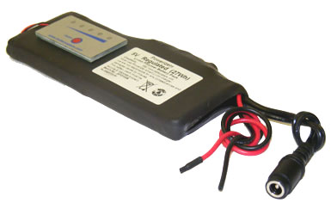

**PCB LAYOUT**

Layout basically means placing or arranging things in a specific order on the PCB. Layout means placing of components in an order. This placement is made such that the interconnection lengths are optimal. At the same time, it also aims at providing accessibility to components for insertion, testing and repair.

The PCB layout is the starting point for the final artwork preparation layout design and it should reflect the concept of final equipment.

There are several factors which we must keep in mind for placing the layout:

**Schematic:**

The schematic diagram forms main input document for preparation of the layout. For this purpose the software for PCB design, ALTIUM is used

**Electrical and thermal requirement:**

The PCB designer must be aware of the circuit performance in critical aspects of the same

concerning electrical conditions and the environment to be used in.

**Mechanical requirement:**

The designer should have the information about the physical size of the board, type of installation of board (vertical/horizontal). The method of cooling adopted, front panel operated components etc.

**Component placing requirement:**

All components are to be placed first in a configuration that demands only the minimum length for critical conductors. These key components are placed first and the others are grouped -around.

**Components mounting requirements:**

All the components must be placed parallel to one another as far as possible i.e. in the same direction and orientation mechanical over stressing of solder should be avoided.

1. **POWER BUDGET**

|  |  |  |  |
| --- | --- | --- | --- |
| **Part Name** | **Quantity** | **Supply Current**  **(mA)** | **Supply Voltage**  **(V)** |
| **Pressure Sensor**  **(Strain gage)** | 8 | 10 or less | Less than 5 |
| **Bluetooth Module**  **(RN4020)** | 1 | 16 | 3.3 |
| **Microcontroller**  **(PIC18F4520)** | 1 | 25 | 5 |
| **Battery** | 1 | 365  (for 10 hours) | 5(+/- 0.2) |

* **The total current requirement is: 100mA**
* **Thus total voltage required is: 5V**

**8. SOFTWARE ASPECTS**

We are using different software for our project like Altium, Proteus, and mikroC. Out of these softwares, Proteus is used to build the circuit and see the simulation, whereas Altium is used for PCB designing.

The code is written in C language. So, we used mikroC to write code.It uses subroutines to count the pulses, driving the display, delays.

**Algorithm:-**

1. Start.
2. Connecting 8 analog inputs to microcontroller& convert it into digital value.
3. Sum up all the digital values & calculate average of all.
4. Display the average value.
5. Make an arrangement to get one reference digital value (consider this as full scale pressure value).
6. Find out what percentage of reference value is the acquired value.
7. Store this value in the EEPROM memory of PIC Microcontroller.
8. Repeat this step for n number of cycles.
9. Make an arrangement to send the stored value to a Bluetooth module via UART communication.
10. Erase the memory after transmission is completed and repeat the whole process.
11. Make an app on smartphone to display the values received via Bluetooth.
12. Stop.

**9. CIRCUIT DESIGN**

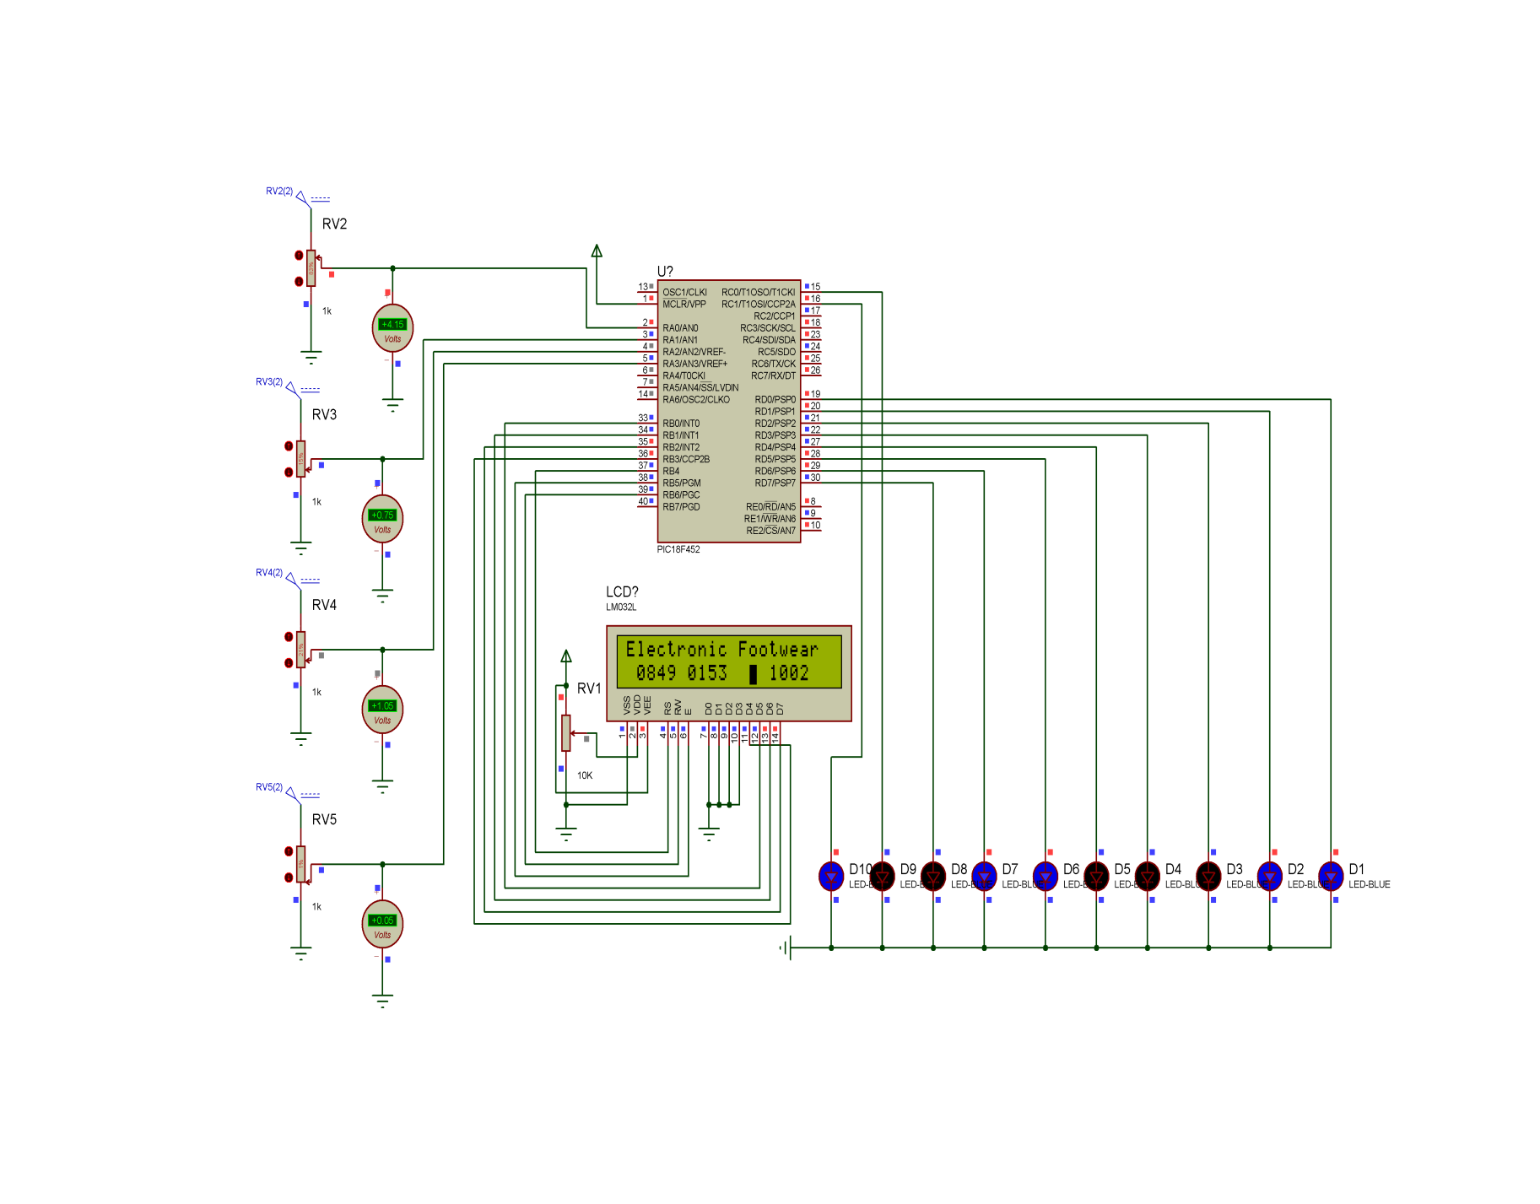

**10. APPLICATION**

Low cost stand-alone system that constantly monitors the weight on injured leg of an orthopaedic patient and is capable of accurately and efficiently measuring foot pressure.

Additional applications:

* An athletic runner can use this device and get acknowledged about various aspects such symmetric loading, correct foot positioning, exhaustion or overload points, etc.
* Daily life Gait monitoring.

**11. CONCLUSION**

* From the project idea we get a clear understanding that selection of component is the major aspect.
* We have thus selected a proper set of hardware components suitable for the project.

Those include Pressure Sensor,Bluetooth, Microcontroller and the Battery.

* We henceforth look forward to complete the simulation procedure and also begin with hardware implementation in mean time.

**12. REFERENCES**

1. [http://www.datasheet4u.com/datasheet pdf/MicrochipTechnology/PIC18F4520/pdf.php?id=511317](http://www.datasheet4u.com/datasheet%20pdf/MicrochipTechnology/PIC18F4520/pdf.php?id=511317)
2. <http://www.csr.com/sites/default/files/microchip_btmp_data_sheet_feb_15.pdf>
3. <http://ww1.microchip.com/downloads/en/DeviceDoc/70005191B.pdf>
4. <https://www.google.co.in/#q=5v%20lithium%20ion%20battery%20pack>
5. <http://ww1.microchip.com/downloads/en/AppNotes/00001861A.pdf>
6. <http://soliton.ae.gatech.edu/people/jcraig/classes/ae3145/Lab2/strain-gages.pdf>
7. <http://soliton.ae.gatech.edu/people/jcraig/classes/ae3145/Lab2/strain-gages.pdf>
8. www.mdpi.com/journal/sensors(Foot Plantar Pressure Measurement System: A Review).
9. http://www.fut-elctronics.com/Tutorial_for_Load_Cell_weight_sensor 50KG.pdf